Android Learning Resource

Software Setup:

Java:

* Verify that you have java. In windows type ‘java -version’ in cmd window (I am using Windows machine)

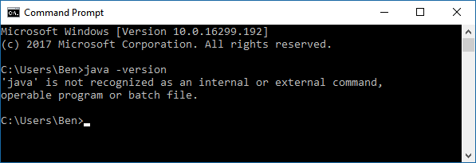

* If there is no java in the machine, then download Java Development Kit
* from  <http://www.oracle.com/technetwork/java/javase/downloads/index.html> and install and verify again.

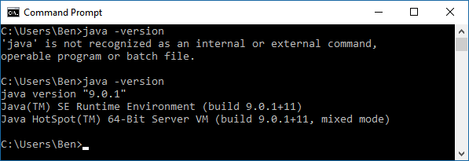

Android Studio

* Download and Install Android Studio (<https://developer.android.com/studio/install.html>)
* Can use free udacity course for installation help. [https://classroom.udacity.com/courses/ud808/lessons/4216368924/concepts/43072785890923#](https://classroom.udacity.com/courses/ud808/lessons/4216368924/concepts/43072785890923)
* For version control with GIT, the resource at <http://wii.logdown.com/posts/2013/11/15/android-studio-git-tutorial> will be helpful specially if you are new to Android Studio (AS) and you want integration of GIT within AS.

Time Requirements:

|  |  |  |
| --- | --- | --- |
| Lesson | Hours | Cumulative |
| 1. Important Details | 2 | 2 |
| 2. Crating Project Sunshine | 2 | 4 |
| 3. Connect to the Internet | 3 | 7 |
| 4. Recycler View | 2.5 | 9.5 |
| 5. Intends | 3 | 12.5 |
| 6. Lifecycle | 2 | 14.5 |
| 7. Preference | 3 | 17.5 |
| 8. Storing Data in SQLite | 3 | 20.5 |
| 9. Content Providers | 2 | 22.5 |
| 10. Building Content Provider | 4 | 26.5 |
| 11. Background Tasks | 4 | 30.5 |
| 12. Completing the UI | 2 | 32.5 |
| 13. Polishing the UI | 2 | 34.05 |
| 14. Challenge Course Wrap Up | .05 | 35 |

My Log:

Started 1/11/2018

1/11 Day 01: Reviewed Email and other Materials

1/12 Day 02: Started Setup and Started Lecture. Familiarize yourself with Android Studio.

1/13 Day 03: More Lectures and Started Exercise

* Learned GIT in Android Studio.
* Completed Exercises
  + T01.01, T01.02, T01.03
  + S01.01, S01.02

1/14 Day 04: Break

1/15 Day 05: Started Lesson 3. Completed T02.01

1/16 Day 06: Completed T02.02-T02.03

1/17 Day 07: More lecture still at Lesson 3

Completed Exercises

T02.04-05

1/18 Day 08: Completed T02.06. S02.01, S02.02, and S02.03 completed.

Gave a feed back on a lesson:

// TODO (8) Create a method that will get the user's preferred location and execute your new AsyncTask and call it loadWeatherData

Updated log.

1/19 Day 09: Started Lesson 4. Completed T03.01

1/20 Day 10: Continued Lesson 4. Started T03.02

1/21 Day 11: Found the length of course and created ‘Time Requirements’

1/22 Day 12: Continued Lesson 4. Completed T03.02, T03.03, T03.04, T03.05, T03.07

1/23 Day 13: Started S03.01

1/24 Day 14: Continued S03.01. Complete S03.01. Update Log.

1/25 Day 15: Finished S03.01. Finished Lesson 3.

1/26 Day 16: Started Lesson 4. Finished T04.1, T04.2

1/27 Day 17: Took a break

1/28 Day 18: Took a break

1/29 Day 19 Completed Exercise T04b.01 T04b.02 T04b.03. Updated log. Participated in Forum

1/30 Day 20 Completed Exercise S04.01 – S04.03. Finished Lesson 4. Updated Log. Started Lesson 4. Completed Exercise T05a.01, T05a.02

1/31 Day 21 Completed Exercise T05a.03, Completed T05b.01

2/01 Day 22 Completed T05b.02, T05b.03, S05.01, T06.01, T06.02

2/02 Day 22 Completed T06.03. Looked into why emulator is irresponsive. Tested in Windows PC with API 26 and it worked. Changed the Emulator’s API to 26 and it worked.

2/03 Day 23 Got a book on Android Cook book. Started reading the book.

2/04 Day 24 Break

2/05 Day 25 Break

2/06 Day 26 Completed Exercise T06.04, T06.04, T06.05, T06.06, T06.07, T06.08

2/06 Day 27 Completed Exercise T06.09, T06.10. S06.01, S06.02, S06.03. Completes Lesson 7.

2/07 Day 28 Completed Ex T7.01, T7.02

2/08 Day 29 Read book sql lite, participated in slack/forum

2/09 Day 30 Completed Ex T7.03

2/10 Day 31 Completed Ex T7.04, T7.05, T7.06, S07.01, S07.02, S07.03. Finished Lesson 8. Started Lesson 9. Completes T08.01, T08.02, T08.03. Completed Lesson 9.

2/11 Day 32 Started Lesson 10. Ex T09.01, T09.02

2/12 Day 33 Break. Too much work at work.

2/13 Day 34 Finished Ex T903, T09.04, T09.05, T09.06, T09.07

2/14 Day 35 Finished Ex S09.01, S09.2, S09.03

2/15 Day 36 Finished Ex S09.04

2/16 Day 37 Finished Ex S09.05

2/17 Day 28 Started Lesson on Background Task

2/18 Break

2/19 Completed Ex T10.01, T10.02, T10.03

2/20 Break

2/21 Break

2/21 Break

2/23 Completed Ex T10.04

2/24 Completed Ex T10.05, T10.06

2/25 Completed Ex S10.01, S10.02, S10.03, S10.04, Started Lesson 12

2/26 Comppleted Ex T11.01

2/27 Completed Ex T11.02

2/28 Started T11.03

3/1 Struggled at T11.03

3/2 Break

3/3 Compelted Ex T11.03

3/11 Completed 12.01

3/12 Completed 12.02

3/14 Completed 12.03

3/15 Completed T12.04

Common Trouble Shoot:

The build error with R. Go to tool, Android and Sync the project.